Architecture Document for
HLS - 1 (AIML Models to predict claims frauds (Payer Facing))

.........
HLS - 1 (AIML Models to predict claims frauds (Payer Facing)
Component>-AD-<Version>

Table of Contents

1 Introduction – PART-A 1
1.1 Purpose 1
1.2 Scope 1
1.3 Definitions, Acronyms and Abbreviations 1
1.4 References 1
2 Architectural Goals and Constraints - – PART-B 2
2.1 Reusability 2
2.2 Scalability 2
2.3 Customizability 2
2.4 Extendibility 2
2.5 Use of Existing Business Logic 2
2.6 Time to Market 2
2.7 Portability 2
2.8 Availability 3
3 Productization Assessment – PART-B 3
3.1 Re-Usable Components 3
3.2 Analyze Architectural Frameworks in Repository 3
3.3 Identify and Analyze Open Source and COTS Products 3
4 System Architecture – PART-A/B 3
4.1 Overview - – PART-A 3
4.2 Logical/Functional View - – PART-A 4
4.3 Use Case View – PART-A 7
4.4 Deployment View – PART-B 8
5 Alternative Solutions Considered – PART-B 10

Introduction – PART-A

Purpose

This document provides a comprehensive architectural overview of the AIML Models to predict claims frauds (Payer Facing) system, using a number of different architectural views to depict different aspects of the system. It is intended to capture and convey the significant architectural decisions, which have been made on the system.

Scope

The scope of this document encompasses the areas directly affected by the Healthcare Fraudulent Detection System. It includes the architectural components, modules, and functionalities involved in detecting and preventing healthcare fraud. The document focuses on providing an overview of the system's architecture and does not cover specific implementation details or operational procedures.

Definitions, Acronyms and Abbreviations

Healthcare Fraudulent Detection System: The system designed to identify and prevent fraudulent activities within the healthcare domain.

Architecture: The overall structure and organization of the system, including its components, modules, and their interactions.

Module: A distinct component or unit of functionality within the system.

Fraudulent Activity: Any deceptive or dishonest behavior intended to gain unauthorized benefits or financial advantage in the healthcare sector.

References

[Reference 1]: Fraud Control in the Health Care Industry: Assessing the State of the Art, Available at https://www.ojp.gov/pdffiles1/172841.pdf
[Reference 2]: A Comprehensive Study of Healthcare Fraud Detection based on Machine Learning, https://www.ripublication.com/ijaer18/ijaerv13n6_140.pdf
[Reference 3]: Medicare fraud detection using neural network, Document Number https://journalofbigdata.springeropen.com/articles/10.1186/s40537-019-0225-0

Architectural Goals and Constraints -– PART-B

This section describes the requirements, objectives, and constraints that have a significant impact on the architecture of the AIML Models used to predict claims frauds (Payer Facing).

Reusability
The AIML models developed for claims fraud prediction should be designed with reusability in mind. The core components and algorithms should be modular and reusable in future projects or enhancements related to fraud detection in the payer domain.

Scalability

The system should be able to handle increasing volumes of claims data efficiently. It should be scalable to accommodate the growing number of claims processed by the payer organization.

Customizability

The user interface (UI) of the claims fraud prediction system should support customization. It should allow users to tailor the UI to their specific needs and preferences.

Extendibility

The system architecture should support the addition of new features and functionalities without major disruptions. It should be designed to allow modular development, enabling easy integration of future enhancements.

Use of Existing Business Logic

The AIML models should leverage the existing business logic and rules used in the payer organization's current fraud detection system. The goal is to integrate the AIML models seamlessly with the existing infrastructure by encapsulating the business logic in reusable components.

Time to Market

The development of the AIML models for claims fraud prediction is subject to time constraints. The architectural choices and technology selection should consider the time-to-market requirements.

Portability

The AIML models should be designed to be portable across different operating systems (OS) and databases. The system should not be tightly coupled with any specific OS or database, allowing for easy deployment in various environments.

Availability

Uptime constraints and fault tolerance needs.

Productization Assessment – PART-B

Re-Usable Components

- The Productization specialist has performed a reuse analysis based on the requirements document. The following reusable components have been identified for the AIML Models to predict claims frauds (Payer Facing) system:
- Data preprocessing module: A component responsible for data cleansing, normalization, and feature engineering. This module can be reused in future fraud detection projects within the payer domain.
- Feature selection module: A component that selects relevant features from the claims data for input to the AIML models. This module can be reused in other AIML-based projects for fraud detection.
- Model evaluation module: A component that assesses the performance of the AIML models and provides metrics such as accuracy, precision, recall, and F1 score. This module can be reused in other AIML model evaluation scenarios.

Analyze Architectural Frameworks in Repository

- The architectural frameworks in the repository have been analyzed to identify potential reuse in the current system. The frameworks suitable for the AIML Models to predict claims frauds (Payer Facing) system include:
- Machine learning frameworks: Frameworks such as TensorFlow, scikit-learn, or PyTorch can be utilized for developing and training the AIML models.
- Data processing frameworks: Frameworks like Pandas can be employed for efficient data processing and manipulation.
- Evaluation frameworks: Frameworks like scikit-learn or Keras provide tools for evaluating the performance of AIML models.

Identify and Analyze Open Source and COTS Products

- The Productization specialist has identified the following open source and Commercial Off-The-Shelf (COTS) products suitable for the AIML Models to predict claims frauds (Payer Facing) system:
- Open-source libraries: TensorFlow, scikit-learn, and Keras can be used for developing and implementing the AIML models.
- COTS fraud detection solutions: Commercial products like SAS Fraud can be analyzed for their compatibility and integration potential.

System Architecture – PART-A/B

This section describes the software architecture of the current system, and how it is represented. Out of the Logical, Use Case, Implementation, Process and Deployment views, it enumerates the views that are necessary, and for each view, explains the types of model elements it contains.

Models | Model.h5(autoencoder)
Diagrams | .svg format

Overview -– PART-A

The AIML Models to predict claims frauds (Payer Facing) system consists of several architectural components organized into three tiers: User Interface Services, Business Services, and Data Services. These layers handle distinct areas of the application and communicate through defined interfaces.
The application is divided into three tiers: User Interface Services, Business Services and Data Services. Each layer is responsible for handling a well-defined area of the application.

Logical/Functional View - – PART-A

The logical/functional view of the system architecture provides a high-level representation of the system's structure and relationships. It includes the following:
Logical components of the layers: This view illustrates the logical components within each layer, such as the user interface components, fraud prediction models, data processing modules, and evaluation modules.
Logical relationships between components: The diagram depicts the logical relationships between the components, showcasing how the user interface interacts with the business services, which in turn interact with the data services.

Option 1: (Use block diagrams)

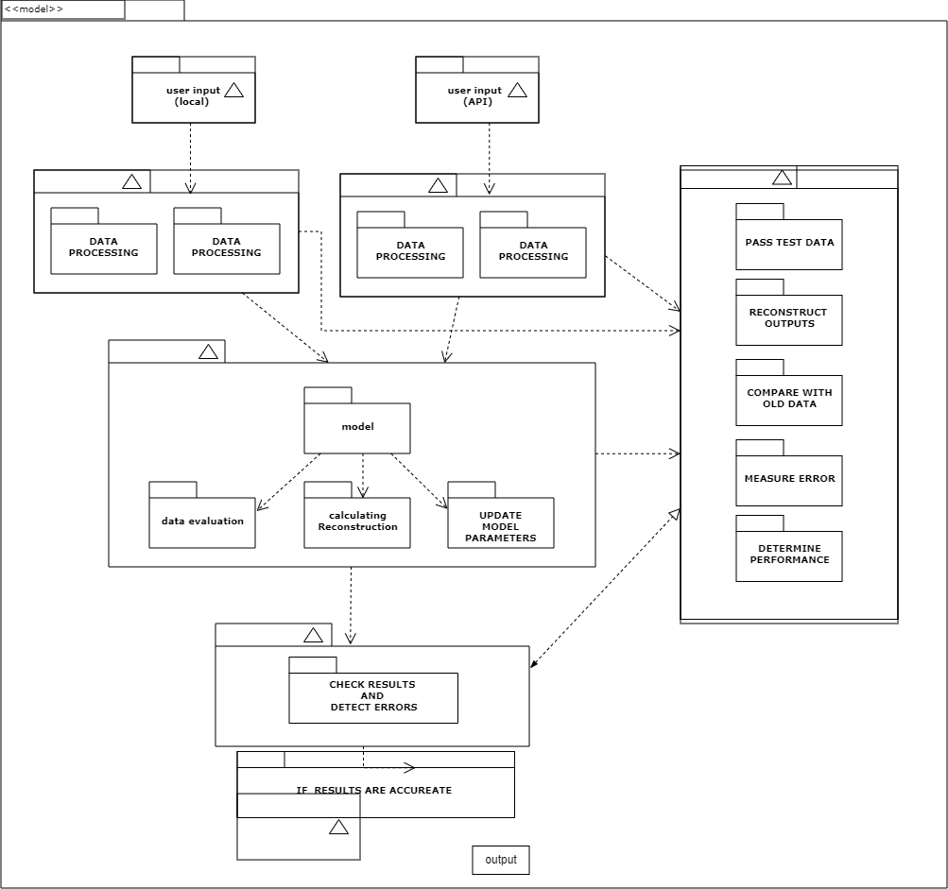

FIGURE 1: Sample Project Application Architecture Overview
Option 2: Package and Layering Diagram (preferred)

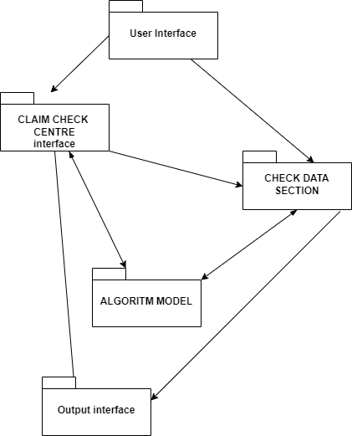

The application is divided into three tiers: User Interfaces Services, Business Services and Data Services. Each layer is responsible for handling a well-defined area of the application.

Use Case View – PART-A

[This sub-section lists use cases or scenarios from the use-case model if they represent some significant, central functionality of the system, or if they have a large architectural coverage - they exercise many architectural elements, or if they stress or illustrate a specific, point of the architecture.]
Example diagram:
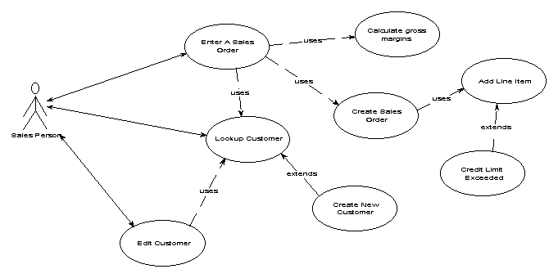
Example diagram:
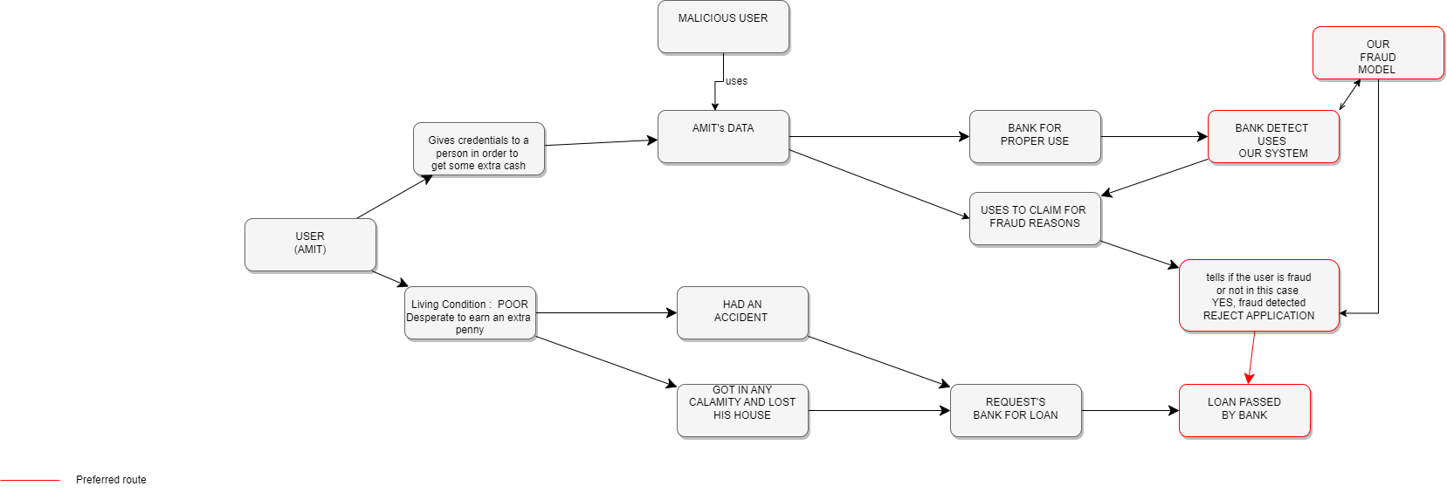

Deployment View – PART-B

[This sub-section describes one or more physical network (hardware) configurations on which the software is deployed and run. It is a view of the Deployment model. At a minimum, for each configuration it should indicate the physical nodes (computers, CPUs) that execute the software, and their interconnections (bus, LAN, point-to-point, and so on.) Also include a mapping of the processes of the Process View onto the physical nodes.

This section also describes the deployment environment.]

Example diagram:

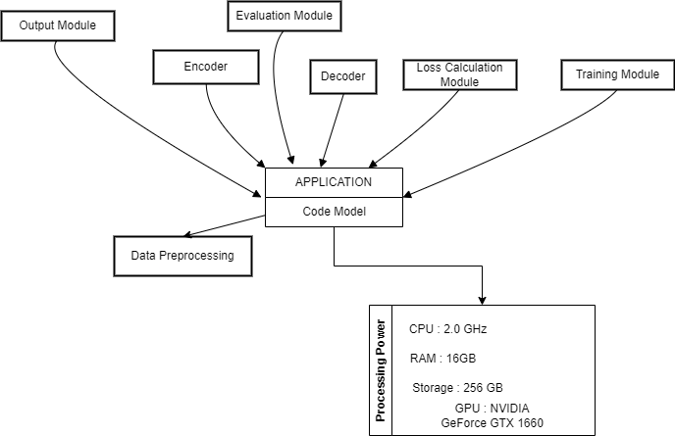

Alternative Solutions Considered – PART-B

[This section describes the alternative architectural solutions that have been considered and explains the rationale for selecting the current solution.]

